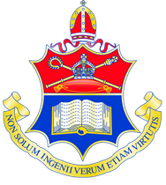 Liverpool College

OPEN EVENTS FOR YEAR 7 2020

We are holding two Open Events for families considering Liverpool College as a Year 7 option.

Wednesday 19th June between 4pm – 6pm
(with last presentation and tour at 5.15pm)
Saturday 14th September between 9.30am – 12 noon
(with last presentation and tour at 11.15am)

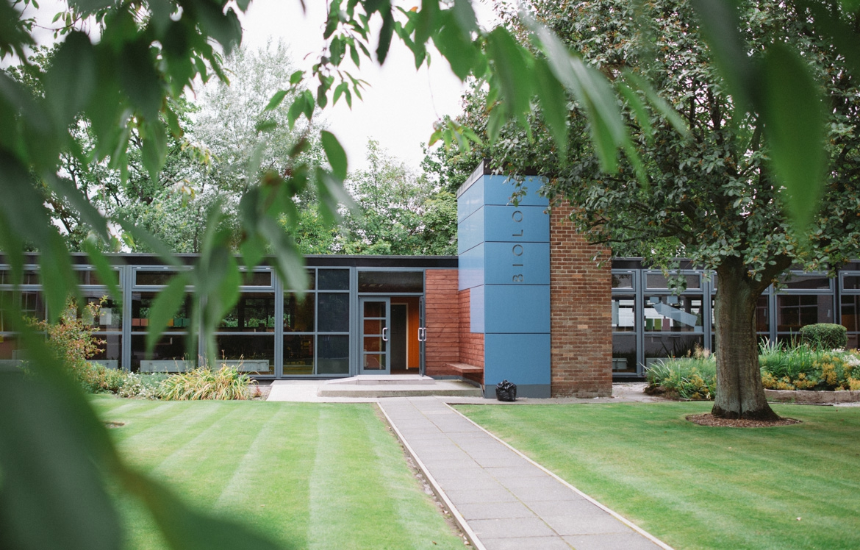

The timetable for Year 7 admissions is as follows:
Deadline for applications : Friday 20th September 2019
Banding Test : Saturday 12th October 2019

There is no need to book an appointment for the open events but if you would like further information please contact
Sally Loveridge 724 4000 ext 3228 or look at our websiteite:
www.liverpoolcollege.org.uk

